School of Biomedical Sciences
Standard Operating Procedures

Title | 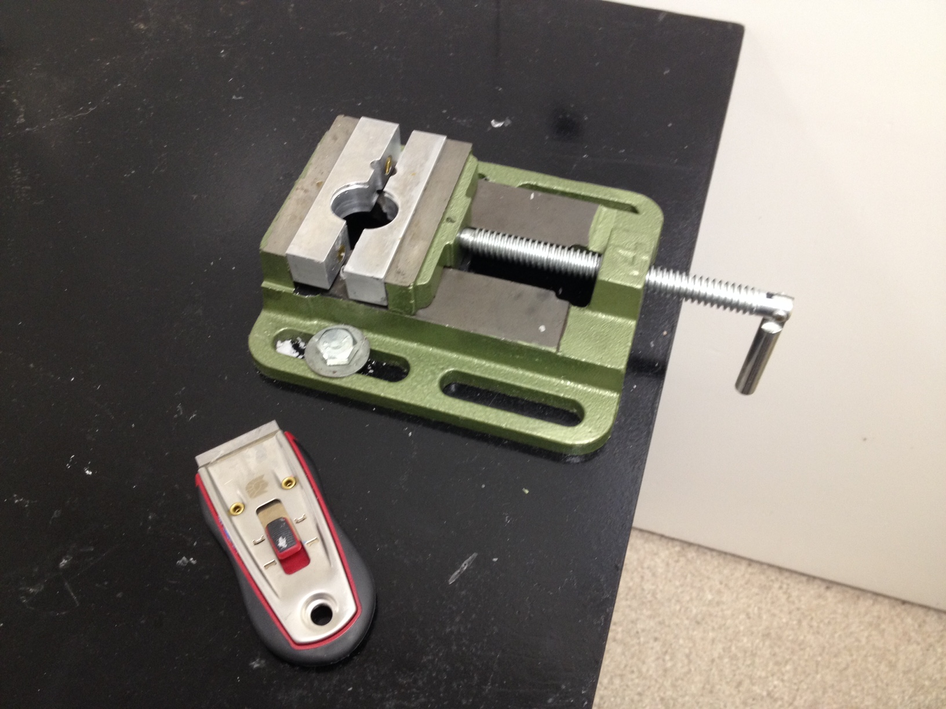  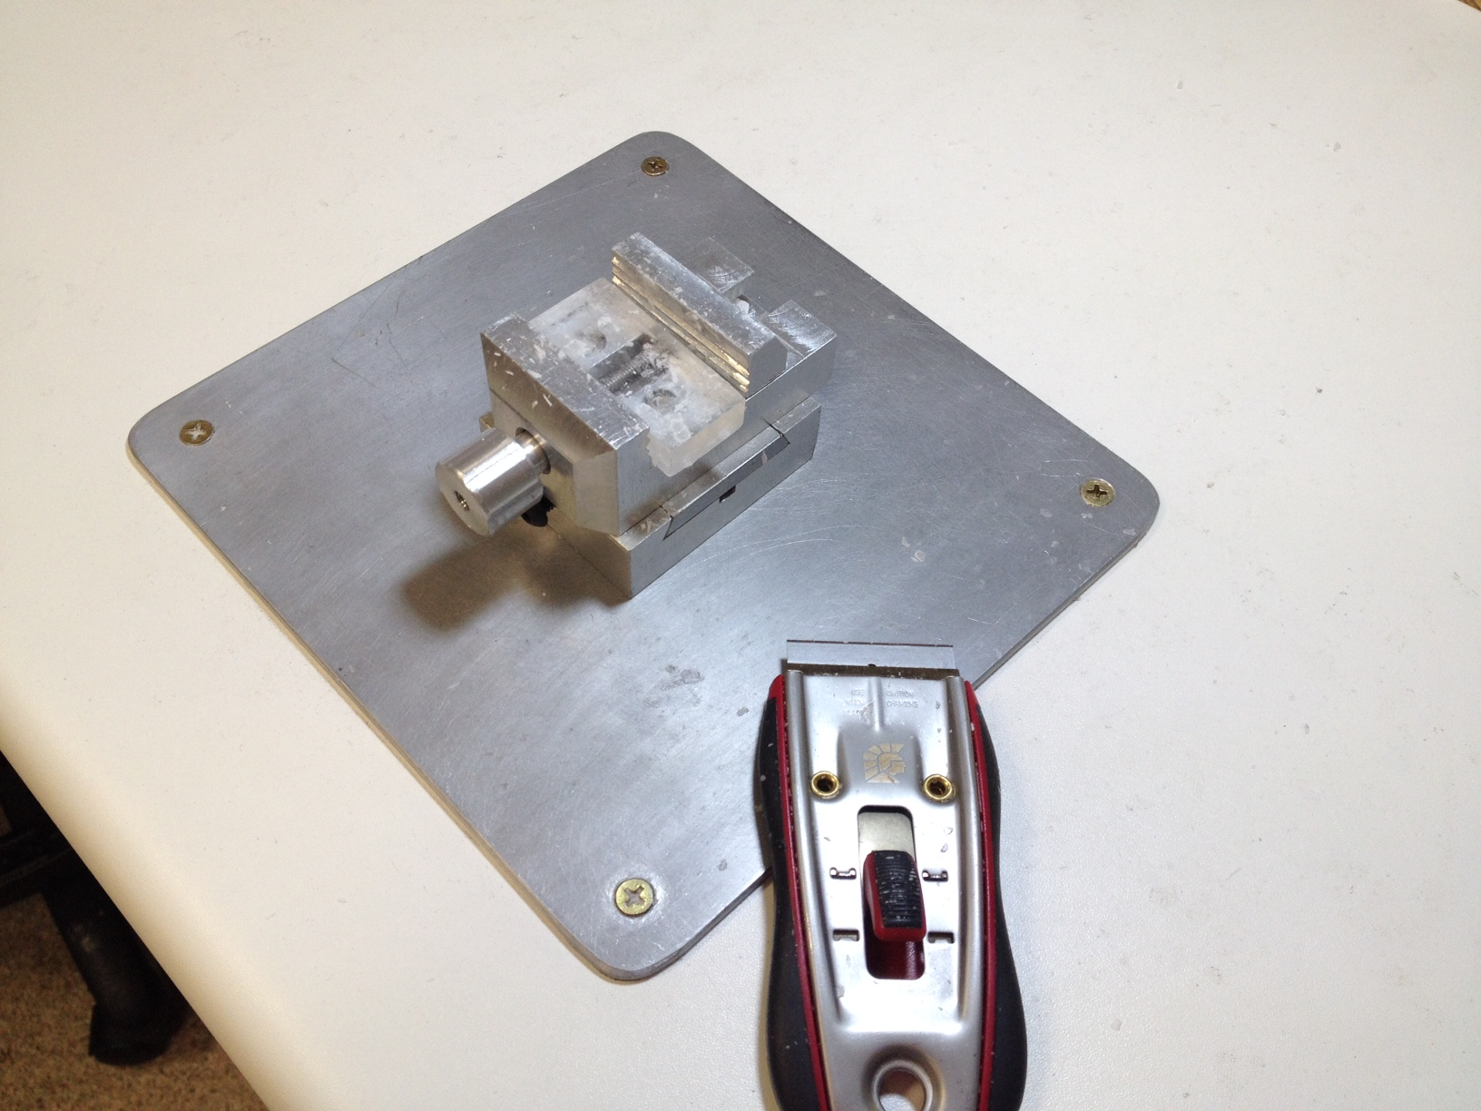  Histological sample shaping using bench clamps
Date | 11/04/2022
Location | Bld: 65 Skerman Room: 210 and 215
Equipment  Custodian | Contact: Darryl Whitehead | Expert user: Darryl Whitehead
Task | This task is performed on both human and animal specimens that have either been embedded in wax for microtome sectioning, or frozen in OCT for cryosectioning. The task requires samples to be clamped into position, and with the use of a single edge razor holder, samples are shaved down to the required shape and size.
Pre start checks | - Ensure all materials are prepared before commencing procedure including all instruments, and that tissue, disposal method, start up and finish materials/ procedures are in place.  - Ensure the blade is held securely within the holder at all times.
Safety considerations | Personal Protective Equipment (PPE): safety glasses (RA), lab coat, gloves (RA) and fully enclosed shoes,  General precautions:  - Long hair must be tied back; loose objects from head/neck/ sleeve area must be covered by lab coat.  - Always alert your supervisor if you or someone around you is feeling ill/faint  - Do not do this procedure in a position where you are likely to be bumped into, and that there is adequate lighting for the procedure.  - Properly place dissection specimens on the bench, do not dissect a specimen whilst holding it. Use clamps where possible.  - Handle scalpels, and other sharp instruments with care, do not wave around or use instruments in a manner not designed for its purpose. Do not walk around lab area with a scalpel blade.  - Cut away from the body and away from other persons  - Avoid excessive force when working with sharp scalpels, use scissors where possible  - Specimen parts are not to leave the laboratory unless instructed by a supervisor.  - Cover sharp protrusions in dissections specimen, such as bones with calico to prevent injury during dissection  - Emergency Procedures:  In the case of a minor cut, remove gloves or contaminated clothing, and wash hands or cut area thoroughly. Seek first aid.  For major cuts or emergency,  All incidents should be reported to the Facility Staff and Manager, Ext 51929, Safety Coordinator, Ext 53221, and/or Security 53333.  All injuries must be reported to SBMS HSW Management, Ext 53221 or 51269, Building Management, Ext 53105.  All incidents and injuries must be recorded in the UQ Incident and Injury Database.
Procedure | Inserting single edge blade on handle.  - Ask histology staff to assist you.  - Push the retractor all the way up. This will open the mouth of the blade holder.  - Carefully slide the new blade in and release the retractor.  - Slide the retractor all the way down until it has clicked into the lock phase. The knife should not be exposed at any time unless shaping the sample.  Mounting specimens into the clamp and shaping  - Loosen the clamp.  - Place your specimen in the holder.  - Tighten the clamp so that the sample is secure.  - Use the knife holder to shape your block. Always cut away from the body. Use both hands to hold the knife. Never place your hands on the sample to steady it, the clamp should be doing this for you.  - Once sample has been successfully shaped, retract the knife into the lock position.  - Loosen the clamp and remove sample.  - Dispose of any waste appropriately.  Blade Disposal  - Single edge razor blades must only be disposed of in yellow sharps bins.
Legislative requirements | - AS 2243. Safety in Laboratories.

Date of issue: 11/04/2022 Next review: 11/04/2025

