School of Biomedical Sciences
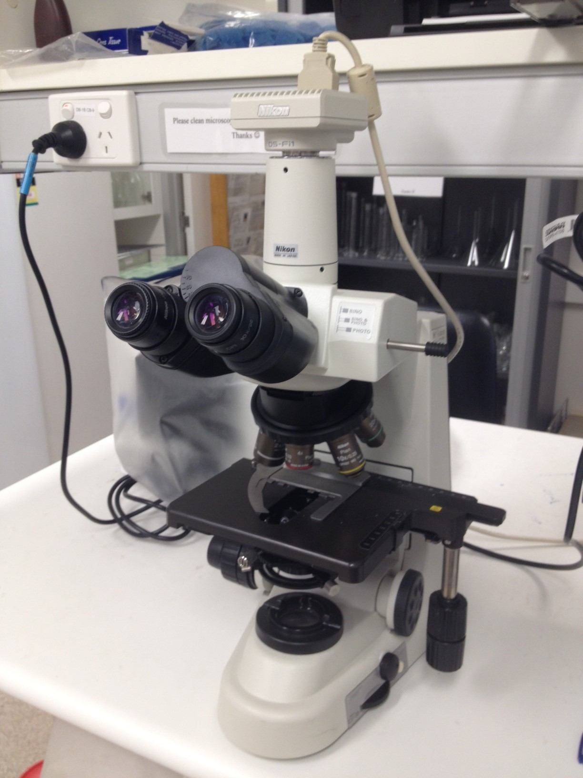
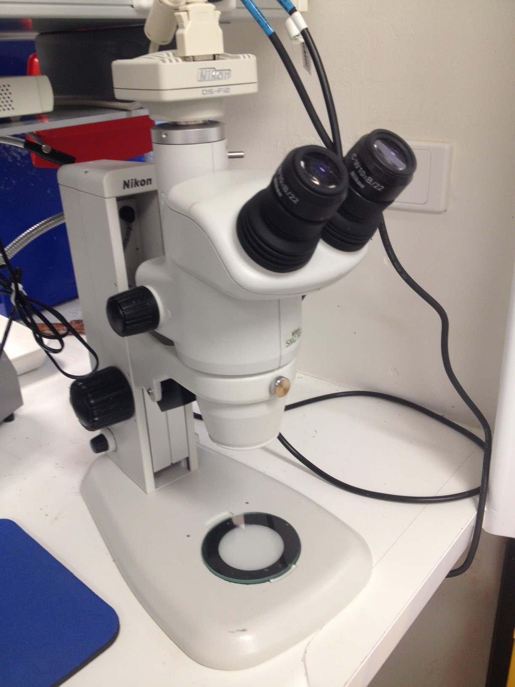
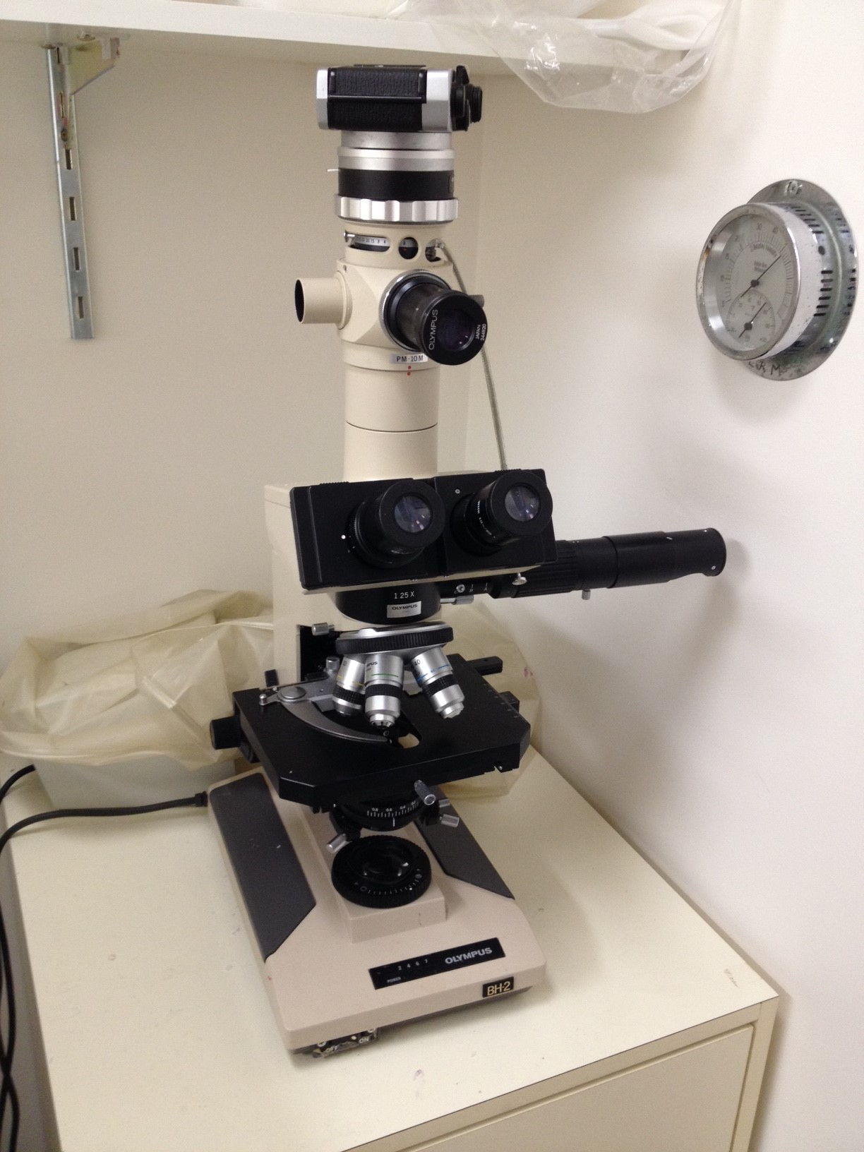
Standard Operating Procedures

Title | Use of microscopes
Date | 11/04/2022
Location | Bld: 65 Skerman Room: 210 & 215
Equipment  Custodian | Contact: Darryl Whitehead | Expert User:  Darryl Whitehead
Task | Users may use the microscopes available in the histology facility to check slide staining, check cutting location of tissue, dissect tissue, or to take a snapshot of tissue.
Pre start checks | - Complete SBMS OH&S Induction and local histology induction  - Obtain equipment specific training provided by the Senior histologist  - Read and understand SOP and Risk Assessments  - Book appropriate device using the SBMS Online Booking System. Histology users are given priority for the scopes. Scopes can be booked for brief periods by booking under ‘sliding microtome’. Please specify in the booking description that the booking is for scope use only.
Safety considerations | Personal Protective Equipment (PPE):  - Lab coat or gown  - Fully closed shoes  - Gloves  - Safety glasses as required  General precautions:  - Check the back and sides of slides are dry and clean prior to placing them on the microscope stage.  - If the mounted slides are not dry, please refrain from using the scopes.  - If mounted slides are not dry, and slide checking is imperative, please do not use 40x or 100x objectives.  - When placing/removing slides, take care not to bump objectives.  - Always use clean absolute ethanol to gently clean 100x oil objective following use.  - Keep the microscope clean.  - Emergency Procedures:  If there is a minor sharps injury: remove gloves and wash hands well. Seek first aid.  In the case of emergency,  All incidents should be reported to the Facility Staff and Manager, Ext 51929, Safety Coordinator, Ext 53221, and/or Security 53333.  All injuries must be reported to SBMS HSW Management, Ext 53221 or 51269, Building Management, Ext 53105.  All incidents and injuries must be recorded in the UQ Incident and Injury Database.
Procedure | - Check slides are dry prior to microscope use. If dissecting samples, always dissect in a glass petri-dish or metal plate, never dissect on the scope stage.  - Remove dust cover from scope.  - Always start at the lowest objective position ie. 1x or 2x objectives  - Place slide onto the scope stage, clip in place so slide does not move.  - Turn microscope power on.  - Adjust the light brightness as required.  - Find tissue or cells of interest using the x and y stage scrollers.  - Use course and fine focus to focus on regions of interest.  - Go to higher objectives for increased magnification and clarity of regions of interest.  - If needed, take a snapshot on the computer.  - When slide viewing is completed, return lowest objective to the start position.  - Remove slide off the stage.  - Turn the power off. Wipe the stage clean using ethanol.  - If 100x oil objective was used, ensure it is cleaned carefully with ethanol after use.  - Cover the microstage with dust covers after use.
Legislative requirements | - AS 2243.6 Safety in laboratories, mechanical aspects

Date of Issue: 11/04/2022 Date of next review: 11/04/2025

