School of Biomedical Sciences
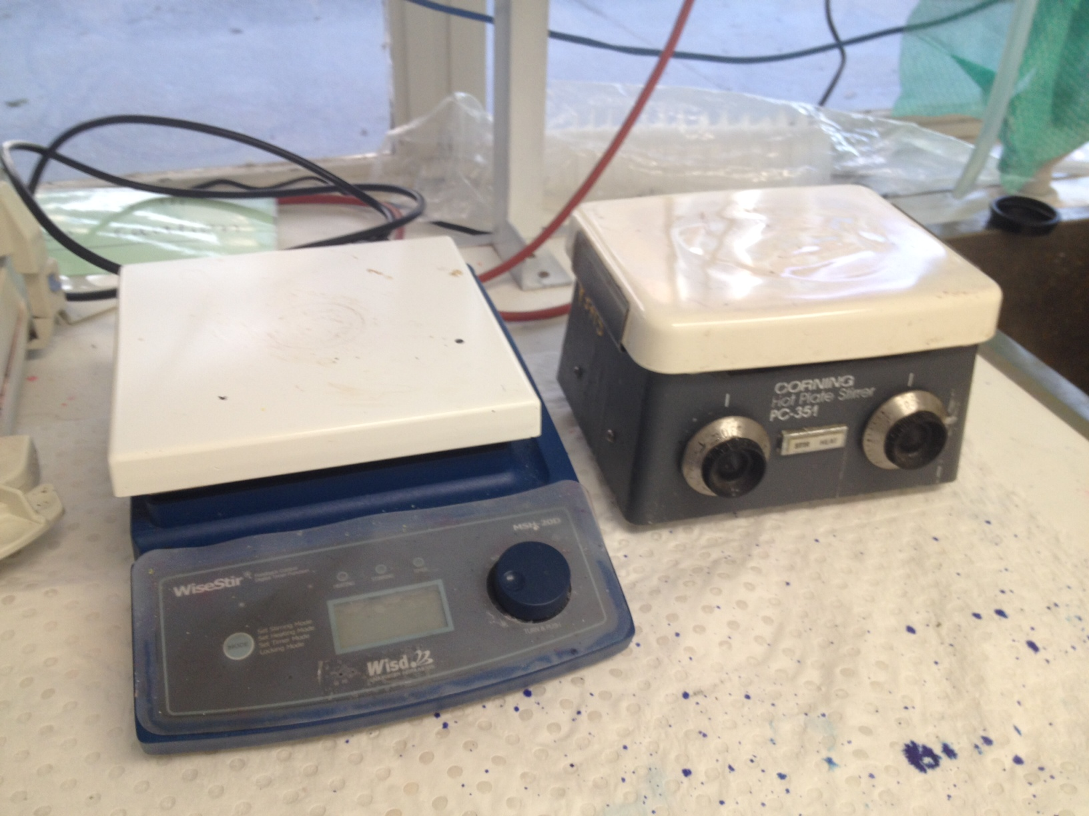
Standard Operating Procedures

Title | Operating hot plates and heat stirrers
Date | 11/04/2022
Location | Bld: 65 Skerman Room: 210
Equipment  Custodian | Contact: Darryl Whitehead | Expert User:  Darryl Whitehead
Task | Working with hot plates and heat stirrers to assist dissolving and mixing of chemicals into solution. You need general training from Histology Facility staff, usually training for operating hot plates or heat stirrers is given during specific histochemical solution training that require the use of this equipment. Because of the associated hazards, safety must be incorporated into every step of the process to keep fingers, hands and other items protected. Follow the safety tips provided below to keep your fingers and hands safe to prevent exposure to high-temperature burns and chemical splashes.
Pre start checks | - Complete SBMS OH&S Induction and local histology induction  - Obtain equipment specific training provided by the Senior histologist  - Read and understand appropriate SOP and Risk Assessments  - Book appropriate device using the SBMS Online Booking System  - Ensure equipment is correctly tagged and tested, ensure that the test and tag period has not expired.  - Check the electrical cords, plug and plate has not been damaged. Check for exposed wires, melted, or missing parts. If damage found, please report to Histology staff member immediately, and do not use the equipment.  - Prepare a ‘HOT – Use caution’ sign to place near the hot plate so other lab users will know it is in use and to use caution.  - Check manufacturer’s instructions for use and maximum allowable temperatures; do not exceed this limit.
Safety considerations | Personal Protective Equipment (PPE):  - Lab coat or gown  - Fully closed shoes  - Gloves  - Safety glasses as required  General precautions:  - Long hair must be tied back; loose objects from head/ neck/ sleeve area must be covered by lab coat.  - Do not use near potential fire/ explosion hazards especially flammable chemical/gases. Do not use in fume hood unless absolutely necessary due to chemicals.  - Hot plates are not to be left unattended, when in use.  - Always read SDSs of chemicals being used on a hot plate prior to use. Be aware of any potential hazards from heating or mixing these chemicals.  - Ensure machine settings are reset (no stir, no heat) prior to use to prevent unexpected chemical spills, and temperature changes.  - If transporting equipment to and from an operating fume hood, ensure hot plate is off and cool to touch prior to transportation.  - Place benchcoat underneath the equipment to absorb any spills during heating or stirring.  - Always wear correct PPE when using chemicals.  - If using a magnetic stirrer, always set stir mode to zero prior to adding in stirrer bar. Always check chemical SDS to ensure chemicals being used do not react with metal (if yes, you cannot use a magnetic stirrer). Always use an appropriately sized stirrer bar. Increase speed gradually as required.  - If using a thermometer to check solution temperature, ensure thermometer is held securely with a clamp, and will not obstruct magnetic stirrer activity. Also ensure thermometer is not in direct contact with glass container.  - When work is completed, ensure machine settings are reset (no stir, no heat) for the next user. When cool, wipe plate clean.  - Emergency Procedures:  In the case of emergency:  If a chemical spill has occurred, if chemicals have entered the eye or face, immediately use the emergency eye wash station to flush the eye for 20 minutes minimum. If chemicals contaminated PPE, remove immediately. If chemicals are in contact with skin, use the emergency shower immediately.  In case of a burn, place all burns under running COLD water for 20 minutes.  Contact Darryl Whitehead, 51929 and seek further first aid. For major burns please contact Emergency on ext 53333 for help. Major burns include burns that penetrates full skin thickness, any electrical burn, burns affecting airways, hands, face, or any burn greater in size than a 20-cent piece. These burns must be taken to a medical professional for treatment immediately.  All incidents should be reported to the Facility Staff and Manager, Ext 51929, Safety Coordinator, Ext 53221, and/or Security 53333.  All injuries must be reported to SBMS HSW Management, Ext 53221 or 51269, Building Management, Ext 53105.  All incidents and injuries must be recorded online in the UQ Incident, Injury and Illness Database.
Procedure | The Histology Facility has multiple models of hot plates and heat stirrers, all of which require electrical energy sources. Depending on the model you need to use, the operating buttons or switches may be slightly different.  - Plug hot plate/ heat stirrer into power socket and turn power on.  - Validate heat and stir settings are at zero. Ensure adequate surrounding space for chemical / solution transfers.  - Always ensure correct PPE is worn at all times.  - Place solution in clean glassware to mix onto the hot plate/ heat stirrer. Never use plastic ware.  - Adjust heat and stir settings as appropriate. Always use appropriate heat protective tools/ gloves when handling hot liquids.  - If using a magnetic stirrer, always set stir mode to zero prior to adding in stirrer bar. Always check chemical SDS to ensure chemicals being used do not react with metal (if yes, you cannot use a magnetic stirrer). Always use an appropriately sized stirrer bar. Increase speed gradually as required.  - If using a thermometer to check solution temperature, ensure thermometer is held securely with a clamp, and will not obstruct magnetic stirrer activity. Also ensure thermometer is not in direct contact with glass container. Always use an alcohol thermometer, and never a mercury thermometer. Dispose of all mercury thermometers via UQ Chemwaste.  - If solution is to be heated or stirred for a longer period of time, ensure clear signage.  - Always check for signs of and void splashing and overheating.  - Once chemicals have been successfully dissolved and mixed, return heat and stir settings to zero.  - Turn power off, and unplug the equipment.  - When the equipment has cooled sufficiently, wipe the plate and surrounding bench clean.
Legislative requirements | - AS 2243.6 Safety in laboratories, mechanical aspects

Date of Issue: 11/04/2022 Date of next review: 11/04/2025

