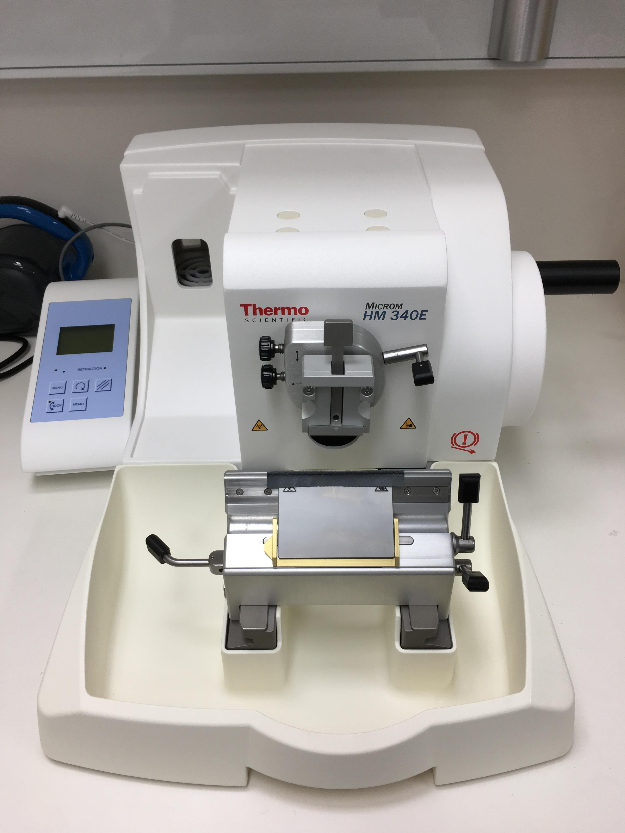
School of Biomedical Sciences
Standard Operating Procedures
Title | Operating the Thermo Microm HM340E Microtome
Date | 11/04/2022
Location | Bld: 65 Room: 210
Equipment  Custodian | Contact: Darryl Whitehead | Expert User:  Darryl Whitehead
Task | Working with microtomes, whether preparing or cutting a sample, is a true art. You need specific hands-on training from the laboratory staff before using a microtome. Because of the associated hazards, safety must be incorporated into every step of the process to keep fingers, hands and other items protected. Follow the safety tips provided below to keep your fingers, hands, and your artistic touch in perfect condition and to prevent exposure to solvents and biological tissues.  Dispose of blades when appropriate or upon completion of work. Do not store disposable blades for future use.
Pre start checks | - Complete SBMS OH&S Induction and local histology induction  - Obtain equipment specific training provided by an expert staff user  - Read and understand associated SOPs and RiskWare Assessment #3253  - Book appropriate device using the SBMS Online Booking System
Safety considerations | Personal Protective Equipment (PPE):  - Lab coat or gown  - Fully closed shoes  - Gloves  - Safety glasses as required  General precautions:  - Handle blades very carefully when installing or removing. Follow the  manufacturer’s guidelines explicitly. Either solid or disposable blades.  - Tungsten-Carbide knives can cut through your shoes if dropped. Be careful where your feet are positioned when installing or removing blades. For solid blades ONLY: Store blades in a covered container. Use a container that has guides to hold the blades rigid.  - Never leave blades on countertops. Lacerations can occur when reaching across the countertop and inadvertently contacting an unprotected blade.  - When setting up the microtome, ALWAYS position the sample first then put in the blade.  - When applying the brake, ensure that it is tight. Most accidents occur when the brake slips and the operator’s hand is drawn into the blade.  - When leaving the microtome, even for a short time, ensure that the blade guard is in place. Place an identification sign on the unit guarding the blade and sample.  - When positioning a paraffin wax block in the microtome, ensure to clamp the cassette sample down tight. The movement allowed by a loose clamp increases your risks of cuts.  - To avoid compression or knife marks, ensure that your blade is clean. Follow the histologist’s guidelines for cleaning the work area. Always use a brush for cleaning the blade, thus removing your hands from potential contact.  - Emergency Procedures:  In the case of emergency, seek and apply first aid immediately (if required).  All incidents should be reported to the Facility Staff and Manager, Ext 51929, Safety Coordinator, Ext 53221, and/or Security 53333.  All injuries must be reported to SBMS HSW Management, Ext 53221 or 51269, Building Management, Ext 53105.  All incidents and injuries must be recorded in the UQ Incident and Injury Database.
Procedure | - Validate that NO knife is present in the mount before continuing.  - Locate power switch at the lower left corner in rear of machine, and turn on.  - Manually retract the knife mount to a safe distance from the clamp and lock  - Place sample into clamp, check sample is tight  - Unlock fine feed wheel and lower clamp to be in-line with knife mount  - Unlock knife mount and bring towards the specimen in the clamp  - Unlock sample clamp and adjust angle and tilt of surface to be parallel with knife mount and relock  - Bring specimen up above knife mount and lock wheel mechanism  - Unlock knife clamp and insert knife from exposed side (no controls or levers)  - Manually bring knife mount closer to the block mount and lock in place  - Validate angle of cutting via the knife mount (~6 °)  - On electrical panel control, set thickness for fine cutting and trimming  - Lower specimen using the rotary wheel to be in line with knife  - Trim specimen to expose tissue  - Transfer to sectioning thickness and cut tissue of interest  - Begin sampling of tissue  Upon completion  - Remove blade and dispose immediately in a clinical sharps container. Do not store disposable blades.  - Remove specimen from microtome, seal surface with paraffin wax if appropriate.  - Brush down and clean microtome with a large brush into the waste collection tray  - Dispose of waste wax in the bin.  - Ensure block mount arm is retracted to the home position.  - Turn off any power sources to the microtome (and accompanying water bath).  - Ethanol wipe down the microtome, and replace cover.
Legislative requirements | - AS 2243.6 Safety in laboratories, mechanical aspects

Date of Issue: 11/04/2022 Date of next review: 11/04/2025

