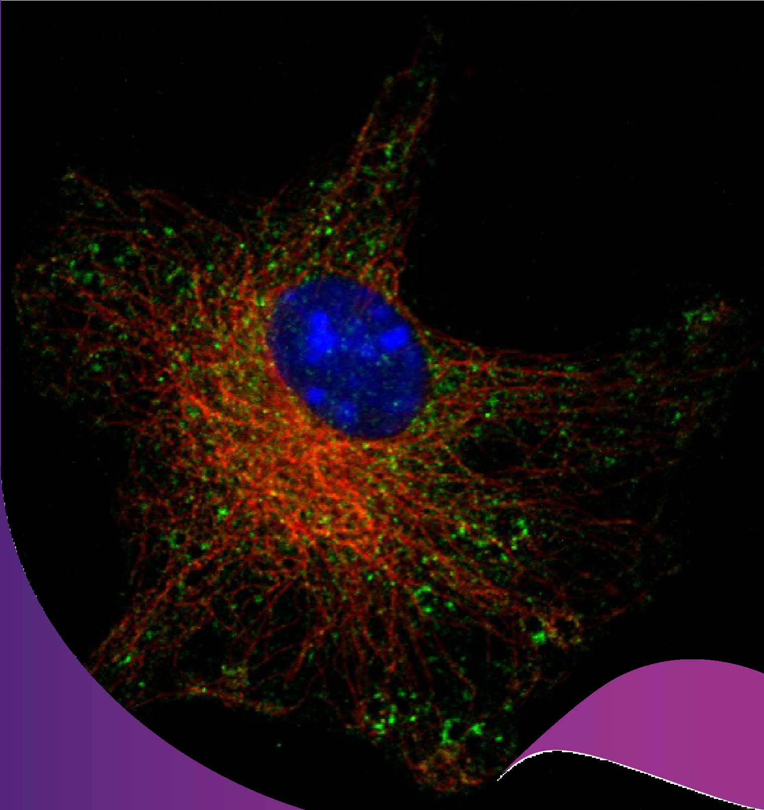

Honours Application

& Enrolment Guide 2025

Bachelor of Biomedical Science (Hons)

Bachelor of Science (Hons) Biomedical Science & Cell Biology

Bachelor of Advanced Science (Hons) Biomedical Science & Cell Biology

# TABLE OF CONTENTS

TABLE OF CONTENTS 2

School of Biomedical Sciences Honours Program Webpage 2

GENERAL INFORMATION ABOUT HONOURS 3

PROGRAM DESCRIPTION 4

Indicative Learning Activity schedule 5

Calculation of Class of Honours 5

HONOURS ENROLMENT REQUIREMENTS 6

HOW TO FIND AN HONOURS SUPERVISOR/PROJECT 7

Key Features of a High-Quality Biomedical Sciences Research Project. 7

Projects within the School of Biomedical Sciences 8

Projects across UQ and affiliated institutes 8

This handbook is intended to give information on how to apply and enrol into the Honours program of the School of Biomedical Sciences. All information provided here is advisory and does not in any way replace The University of Queensland’s Academic Calendar and/or the Electronic Course Profile

# School of Biomedical Sciences Honours Program Webpage

Further information regarding School of Biomedical Sciences Honours Program is available at the following website:

<https://biomedical-sciences.uq.edu.au/study/honours>

# GENERAL INFORMATION ABOUT HONOURS

After completing your Bachelor of Biomedical Science or equivalent degree, Honours will be the most intensive – and for many the first – contact with original research. Through Honours you will experience the different facets of research: the excitement of learning and discovering something new, the satisfaction that comes with becoming an expert in your chosen field of study as well as frustrations when things do not go as planned, troubleshooting and problem-solving around that, and last but not least, the communication of your findings. You will be part of a research team, learning from more experienced researchers around you, such as your supervisors and other members of the laboratory.

The School of Biomedical Sciences is a part of the Faculty of Health, Medicine and Behavioural Sciences, and our Honours students are enrolled through either the Bachelor of Biomedical Science (Honours), Bachelor of Science (Honours), or the Bachelor of Advanced Science (Honours).

Whether you consider Honours a steppingstone to a Master’s or PhD, and then onto a research career, or a vital research experience that gives you credibility for other non-traditional careers in science, you will find that this course adds significantly to your overall training as a science graduate. A Honours degree is most often the minimum qualification required for employment in research positions in both academia and industry. Numerous career opportunities await students with backgrounds in the biomedical sciences, with universities, research institutions, industry and/or government as example employers. Many students have opted to study biomedical sciences as a prelude to careers in professional disciplines such as medicine. Clinician engagement in research is increasingly encouraged and/or expected, and enrolling into Honours is an excellent first step for high-level research training.

Candidates who obtain a Honours I or Honours IIA overall may proceed directly to studies for the degree of Doctor of Philosophy (PhD). An Honours IIB is the minimum requirement for entry to the degree of Master of Science (MSc). The pathway for students aspiring to have careers as academics, researchers and/or clinician-scientists is usually the PhD, which typically is the minimum requirement of employment for such positions.

# PROGRAM DESCRIPTION

The Bachelor of Biomedical Science (Honours) program provides students with the opportunity to pursue an independent research project in the biomedical sciences in a suitable area of interest, and under the supervision of an academic staff member. Students will develop strong quantitative, problem-solving and research skills that will enable them to proceed to a research higher degree, or to work without close supervision in a research environment in the public and private sectors.

[**Biomedical Science Research Preparative Skills (BIOM6070)**](https://programs-courses.uq.edu.au/course.html?course_code=BIOM6070) **– 2 Unit Course delivered both semesters**

In this research preparative skills course, you will learn how to (1) identify reliable resources, (2) design appropriate experiments, (3) critique the work of others, (4) effectively communicate to diverse audiences and (5) build collegial and sustainable networks. The format for this course includes pre-reading, a series of focused interactive workshops and the delivery of small and large assignments that are designed to support your preparation for your honours research project as wells as your future study/careers. By the end of this course, you should have the knowledge and skills required to effectively design, execute and disseminate your research findings in an impactful way.

[**Biomedical Science Research Techniques (BIOM6080)**](https://programs-courses.uq.edu.au/course.html?course_code=BIOM6080) **– 2 Unit Course delivered both semesters**

Success in biomedical research requires knowledge of the experimental techniques used to generate scientific data. Students will learn foundational skills in experimental design, hypothesis testing, biostatistics, and research integrity. A focus on selected research techniques will round out student’s preparation and in-depth background knowledge of the chosen techniques, hands-on demonstrations of critical technologies and analysis of captured datasets. Students will be assessed on their understanding of a range of research techniques, data analysis and the communication of knowledge and results.

*Both these preparative courses are to be completed during the first semester of a student’s enrolment in the School of Biomedical Sciences’ Honours Program before commencement of the research project.*

[**Biomedical Science Research Project (BIOM6100)**](https://programs-courses.uq.edu.au/course.html?course_code=BIOM6100) **– 12 Unit Course commencing Semester 1**

[**Biomedical Science Research Project (BIOM6200)**](https://programs-courses.uq.edu.au/course.html?course_code=BIOM6200) **– 12 Unit Course commencing Semester 2**

Honours students within the School of Biomedical Sciences will undertake their own original research project under the guidance of an academic supervisor based within SBMS or affiliated research institutes. Students will be assessed on the overall quality of their work, in particular their scientific communication skills in both oral and written presentations of their research project.

## Indicative Learning Activity schedule

Each student will need to complete the three subjects. BIOM6070 & BIOM6080 will be completed in your first enrolled semester of the program before you commence your research project.

|  |  |  |
| --- | --- | --- |
| Teaching Week  (First Semester) | Learning activity | Availability to conduct your research project |
| Week 1-5 | BIOM6070 & BIOM6080 curriculum delivery | Not available |
| Week 6 | BIOM6070 Major assessment | Partial availability |
| Week 7-9 | BIOM6100 Research Proposal | Partial availability |
| Week 10-11 | BIOM6100 Research | Full availability |
| Week 12 | BIOM6080 Major assessment | Partial availability |
| Week 13 | BIOM6100 Research | Full availability |

|  |  |  |
| --- | --- | --- |
| Teaching Week (second Semester) | Learning activity | Availability for BIOM6100 research project |
| Week 1-10 | BIOM6100 Research | Full availability |
| Week 11 | BIOM6100 Thesis submission | Not available |
| Week 13 | BIOM6100 Outcomes seminars | Not available |

## Calculation of Class of Honours

*Calculation of the Class of Honours awarded will be determined by a weighted average of the GPA awarded for each of the three subjects on their first attempt.*

| **GPA** | **Class of Honours** |
| --- | --- |
| 6.200 – 7.000 | Class I |
| 5.650 – 6.199 | Class IIA |
| 5.000 – 5.649 | Class IIB |
| 4.000 – 4.999 | Class IIIA |
| <4.000 | Class IIIB |

# HONOURS REQUIREMENTS AND ENROLMENT

1. Check if you meet the entry requirements.

**Bachelor of Biomedical Science** graduates can check their eligibility in enrol into Honours by reading the program rules and requirements [here](https://study.uq.edu.au/study-options/programs/bachelor-biomedical-science-honours-2423#overview).

**Bachelor of Science graduates** can check their eligibility to enrol into Honours by reading the program rules and requirements [here](https://study.uq.edu.au/study-options/programs/bachelor-science-honours-2031#overview).

Students currently enrolled in the 4-year Bachelor of Advanced Science (Honours) program can check their eligibility to enrol into the final Honours year by reading the program rules and requirements [here](https://study.uq.edu.au/study-options/programs/bachelor-advanced-science-honours-2516).

1. Choose a research area you would like to work in and discuss potential projects with a range of possible supervisors (see below for further information).
2. Once a supervisor has agreed, review the [**SBMS Honours Supervisor Policy**](https://biomedical-sciences.uq.edu.au/files/28199/SBMS-Honours-supervisor-requirements.pdf) and ensure your primary supervisor and/or co-supervisors are eligible. **It is required that at least one of the supervisors, i.e. either the Principal Supervisor or Co-Supervisor, is an academic or affiliate of the School of Biomedical Sciences.** If you preferred supervisor is not eligible then discuss options with them; this may include enrolment in more relevant alternative honours programs.
3. Upload the completed [School application form](https://biomedical-sciences.uq.edu.au/files/25808/SBMS-Honours-Application-2025.pdf) to the UQ Online application system when you lodge your application, see step 5 below. If you are a Bachelor of Advanced Science (Honours) student, please email your completed form to [sbms@enquire.uq.edu.au](mailto:sbms@enquire.uq.edu.au) .
4. *Important:* All BBiomedSc applicants, BSc Honours applicants, and other students who are new to UQ must also complete the [UQ Online application form](https://apply.uq.edu.au/)
5. Once we have checked the application details and eligibility based on minimum GPA requirements, you will receive notification advising which courses you need to add in mySI-net. You will need to enrol in these courses before the census date (indicated on the University calendars). If awaiting results, students cannot be enrolled until the outcome of these are released.

All queries about the enrolment process should be directed to

SBMS Student and Academic Administration Team

Email Contact: [sbms@enquire.uq.edu.au](mailto:sbms@enquire.uq.edu.au)

Office Location: Level 1, Macgregor Building (#64) (located next to the Student Hub)

Office Phone Contact: (07) 33651170

**For those commencing Bachelor of Biomedical Science Honours 2027 onwards** these new prerequisites will apply:

Have been awarded a Bachelor of Biomedical Science (or equivalent), with:

* a grade point average (GPA) of 4.5 on a 7-point scale, and
* have secured an honours project and supervisor, and
* satisfied any additional requirements set by the head of school.

# HOW TO FIND AN HONOURS SUPERVISOR/PROJECT

Research projects are selected by negotiation between you and eligible supervisor(s), and then reviewed by the Biomedical Sciences Honours Coordinators for overall appropriateness. To find a supervisor and suitable project, we advise you to identify research areas that you are interested in and then approach staff working in these areas. We encourage you to already seek contact with staff members before or early in your Level 3 studies.

## Key Features of a High-Quality Biomedical Sciences Research Project.

Biomedical scientists provide the foundation of modern healthcare and play a crucial role in developing life-changing treatments and technologies. Throughout the discovery lifecycle from laboratory to clinical application, biomedical scientists are making incredible advances in modern medical science. By understanding how the human body works and what goes wrong in disease, biomedical scientists apply their knowledge to develop new treatments.

While each research project is inherently unique, there are several essential core features that characterise a well-designed and impactful research project in the biomedical sciences:

1. **Clear Rationale and Defined Hypotheses**: A strong research project begins with a clearly articulated rationale and testable hypothesis that addresses a specific gap in current scientific knowledge. The project should aim to make a meaningful, incremental contribution to the broader objectives of the host research group. While groundbreaking discoveries such as curing major diseases may be beyond the scope of a single student project, the work should nonetheless advance understanding within the field.
2. **Generation of Original Experimental Data**: A high-quality project involves the collection of unique experimental data through hands-on experimentation conducted by the student. It should incorporate a variety of experimental techniques—ideally more than three—with the goal of enabling the student to perform these methods independently. Projects that explore new scientific territory often require the development and optimization of custom experimental protocols and reagents. The workload should be substantial, typically requiring more than 30 hours per week to be spent in the laboratory over a period of at least 13 weeks.
3. **Contribution to Scientific Understanding**: Effective projects challenge existing paradigms and contribute to the evolving understanding of biomedical science. As science is a continuous process of problem-solving, each project should aim to generate findings that can be integrated into the current body of knowledge. These findings should also prompt critical evaluation and reflection on established concepts.
4. **Designed for Publication-Ready Outcomes**: The experimental plan should be structured to produce results that are suitable for publication. This includes ensuring that all necessary resources are available, that ethical and regulatory approvals are secured, and also that sufficient time is allocated to complete the work. A well-prepared project increases the likelihood that its outcomes will contribute to the scientific literature.

## Projects within the School of Biomedical Sciences

Our staff in the School of Biomedical Sciences (SBMS) are active in both research and teaching in a wide range of areas, from understanding molecules within cells through to the structure and function of intact humans. Students interested in the biomedical sciences can conduct research into how specific organ systems, tissues, cells and/or molecules function together; conduct research on how drugs modify or affect biological functions or understanding the anatomical function of humans. The types of research projects available include 1) Basic Research projects that will examine how human components normally function; 2) Pathological projects that will examine changes that occur during diseases or injury and 3) Clinical projects focused on the translation of knowledge to influence clinical practice.

To discuss the cutting-edge biomedical research taking place within SBMS and what projects may be available for Honours students, please contact our academics directly at any time, or engage with them during lectures or practical classes on topics of interest to you. More details can be found at https://biomedical- sciences.uq.edu.au/research/themes .

At the University of Queensland’s School of Biomedical Sciences, our research spans 10 research themes.

* [Cell Architecture](https://biomedical-sciences.uq.edu.au/research/cell-architecture)
* [Chronic Diseases](https://biomedical-sciences.uq.edu.au/research/chronic-diseases): cancer, cardiovascular disease, diabetes, neurodegeneration
* [Drug Design and Development](https://biomedical-sciences.uq.edu.au/research/drug-design-and-development)
* [Functional and Comparative Anatomy](https://biomedical-sciences.uq.edu.au/research/functional-and-comparative-anatomy)
* [Injury and Repair](https://biomedical-sciences.uq.edu.au/research/injury-and-repair)
* [Innovation in Biomedical Education](https://biomedical-sciences.uq.edu.au/research/innovation-in-biomedical-education)
* [Musculoskeletal and Motor Control](https://biomedical-sciences.uq.edu.au/research/musculoskeletal-and-motor-control)
* [Neurobiology and Brain Function](https://biomedical-sciences.uq.edu.au/research/neurobiology-and-brain-function)
* [Receptors and Signalling](https://biomedical-sciences.uq.edu.au/research/receptors-and-signalling)
* [Reproduction](https://biomedical-sciences.uq.edu.au/research/reproduction)

Alternatively, another good resource to locate researchers with overlapping interests is the [UQ Experts database of academics](https://about.uq.edu.au/experts). You can search this database for any topics including scientific discipline, disease, experimental techniques, name, etc.

## Projects across UQ and affiliated institutes

You may want to consider eligible supervisors outside of SBMS. Information and contact details for researchers outside of SBMS can typically be found on School and Institute websites, some of which are listed below:

[Australian Institute for Bioengineering and Nanotechnology](https://aibn.uq.edu.au/honours)

[Institute for Molecular Bioscience](https://imb.uq.edu.au/study/honours)

[The Critical Care Research Group - Prince Charles Hospital](https://www.ccrg.org.au/honours-students)

[QIMR-Berghofer Medical Research Institute](https://www.qimrberghofer.edu.au/student-projects/)

[Queensland Brain Institute](https://qbi.uq.edu.au/study/honours)

[UQ Centre for Clinical Research](https://clinical-research.centre.uq.edu.au/honours)

[UQ Child Health Research Centre](https://child-health-research.centre.uq.edu.au/study-chrc)

[UQ Frazer Institute](https://frazer.uq.edu.au/study/)

[UQ Mater Research Institute](https://www.materresearch.org.au/students/future-students/student-research-opportunities)

[UQ Medicine School](https://medical-school.uq.edu.au/research)

