School of Biomedical Sciences
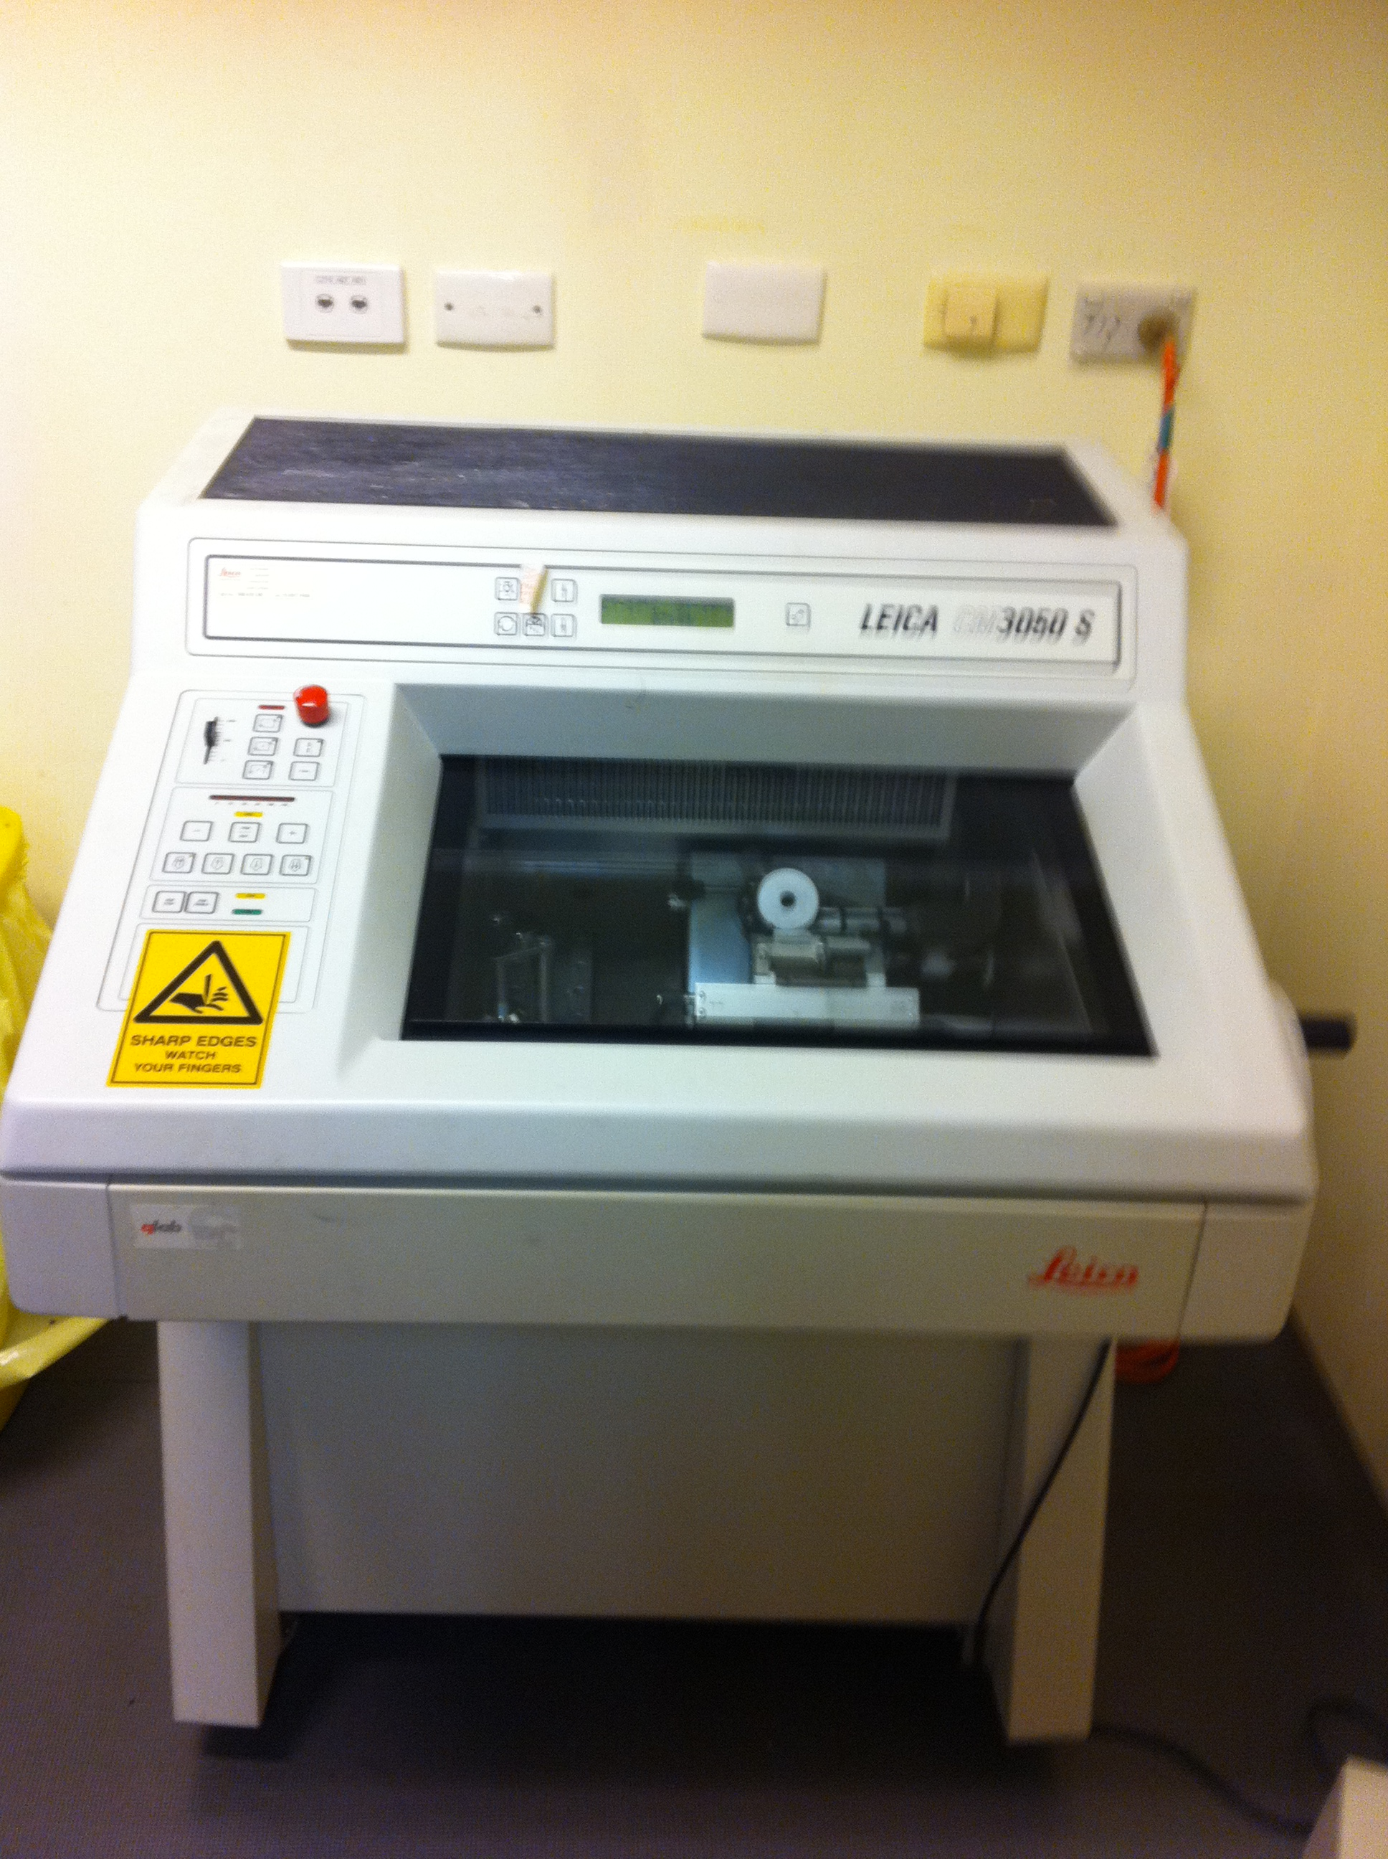
Standard Operating Procedures

Title | Operating the Leica Cryostat
Date | 24 Oct 2014
Location | Bld: 64 Room: 126
Equipment  Custodian | Contact: Darryl Whitehead | Expert User:  Darryl Whitehead
Task | Working with cryostats, whether preparing or cutting a sample, is a true art. You need specific hands-on training from the laboratory supervisor before using a cryostat. Because of the associated hazards, safety must be incorporated into every step of the process to keep fingers, hands and other items protected. Follow the safety tips provided below to keep your fingers, hands, and your artistic touch in perfect condition and to prevent exposure to solvents and biological tissues.
Pre start checks | - Complete SBMS OH&S Induction and local histology induction  - Obtain equipment specific training provided by the Senior histologist  - Read and understand SOP and Risk Assessments  - Book appropriate device using the SBMS Online Booking System
Safety considerations | Personal Protective Equipment (PPE):  - Lab coat or gown  - Fully closed shoes  - Gloves  - Safety glasses as required  General precautions:  - Handle blades very carefully when installing or removing. Follow the  Manufacturer’s guidelines explicitly.  - Store blades in a closed container. Use a container that has restricts access to the blade edge.  - Never leave blades on countertops or within the cryostat chamber. Lacerations can occur when reaching across the countertop and inadvertently contacting an unprotected blade.  - When setting up the cryostat, ALWAYS position the sample first then put in the blade.  - When applying the brake, ensure that it is locked. Most accidents occur when the brake slips and the operator’s hand is drawn to the blade.  - When leaving the cryostat, even for a short time, ensure that the blade guard is in place. Place the Identification sign, including name and contact details, on the unit guarding the blade and sample. If away for a long period of time please remove the blade.  - To avoid compression or knife marks, ensure that your blade is clean. Follow the histologist’s guidelines for cleaning the work area, item #14 as below. Always use a brush for cleaning the blade, thus removing your hands from potential contact.  - Dispose of blades when appropriate or upon completion of work into an approved sharps container.  - Emergency Procedures:  In the case of emergency,  All incidents should be reported to the Facility manager, Ext 51929, Safety Coordinator, Ext 53221, and/or Security 53333.  All injuries must be reported to SBMS OHS either to Robyn Oram, Ext 53221, Neville Barry, Ext 53105, Bruno Ray, Ext 52724, or Lawrie Myers, Ext 51269.  All incidents and injuries must be recorded in the UQ Incident and Injury Database.
Procedure | - Press lock button and hold for over 5 sec in order to activate the machine  - Validate that NO knife is present in the knife carrier  - Retract knife carrier to a safe distance from the clamp and lock  - Place sample into sample clamp and validate its locking  - Unlock sample clamp and adjust angle of surface to be even with knife carrier and relock  - Open guard, unlock knife clamp and insert knife from exposed side (no controls or levers)  - Validate knife edge to be level on the knife ridge and lock  - Bring knife to specimen to validate mounting angle and lock in place  - Set the object and cutting temperature  - Set the course and fine cutting thickness  - Use course feed to minimize gap  - Depress clamp lock and shape the specimen using course feed  - Validate unit is in the single cut mode and begin sampling of tissue  - Clean stage with a paint brush by brushing away from the knife edge, when necessary or after each cut is mounted on the slide  - At the end of each work session, remove the knife blade, dispose of it into the sharps bin, and clean the cryostat by brushing all waste samples and tissues into the trap  - Removes the trap and empty all debris into the pathological waste bin  - Wash the chamber, mount, knife mount and other areas with EtOH  - Close the guard door, turn off the light, and press the lock button for 5 secs in order to turn the machine off.  Lifting the Samples  - Use glass guard when possible or brushes to capture the specimen cuts  - Flatten samples with fine brushes  - Rapidly contact slide with the specimen  - Remove slides from the chamber to maintain temperature difference
Legislative requirements | - AS 2243.6 Safety in laboratories, mechanical aspects

Date of Issue: 24 Oct. 14 Date of next review: 24 Oct. 17

