School of Biomedical Sciences
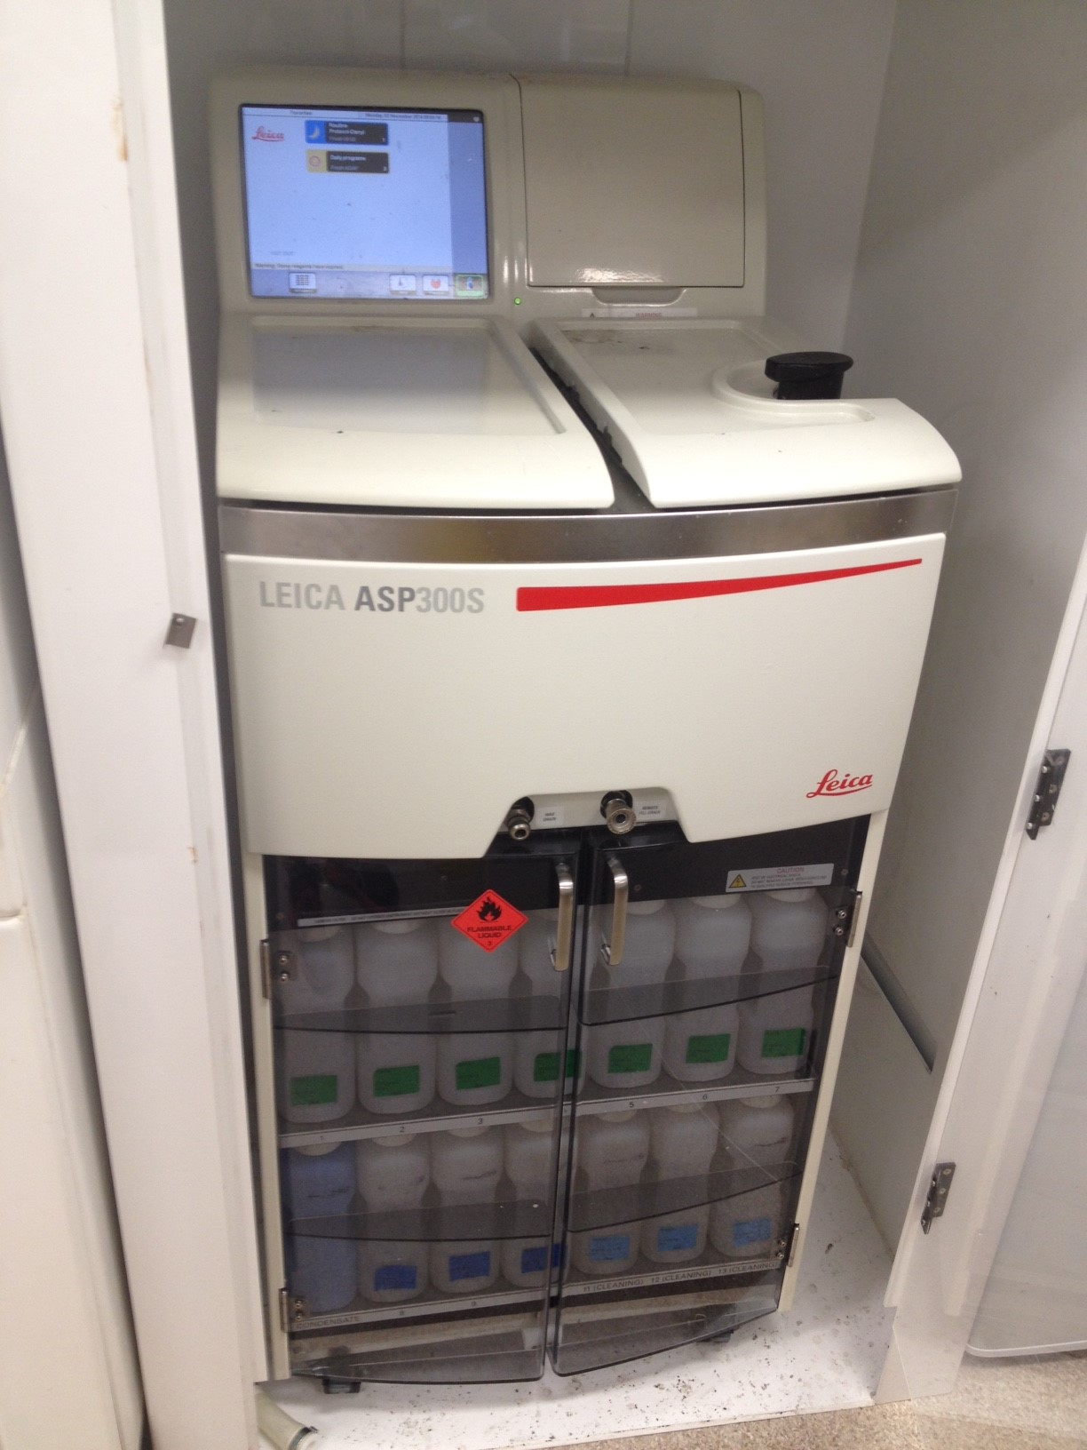
Standard Operating Procedures

Title | Operating the Leica ASP200S automatic tissue processor
Date | 30 October 2014
Location | Bld: 64 Room: 126
Equipment  Custodian | Contact: Darryl Whitehead | Expert User:  Darryl Whitehead
Task
Pre start checks | - Complete SBMS OH&S Induction and local histology induction  - Obtain equipment specific training provided by the Senior histologist  - Read and understand SOP and Risk Assessments  - Book appropriate device using the SBMS Online Booking System
Safety considerations | Personal Protective Equipment (PPE):  - Lab coat or gown  - Fully closed shoes  - Gloves  - Safety glasses as required  General precautions:  - Take care when using to avoid hot surface areas as they may cause burns  - Avoid contact with hot wax as it may cause burns  - Always validate that a sufficient amount of wax and stock chemicals are within the stock tank and bottles.  - Validate the wax is fully melted before usage  - Clean all tissues from the machine upon completion of its usage  - Take care when obtaining new metal rack from within the pathcentre as they may contain melted wax, even when in the storage area  - Emergency Procedures:  In the case of emergency,  All incidents should be reported to the Facility manager, Ext 51929, Safety Coordinator, Ext 53221, and/or Security 53333. All injuries must be reported to SBMS OHS either to Robyn Oram, Ext 53221, Neville Barry, Ext 53105, Bruno Ray, Ext 52724, or Lawrie Myers, Ext 51269. All incidents and injuries must be recorded in the UQ Incident and Injury Database.
Procedure | Running the tissue processor  - Turn on evaporation fan above unit  - Obtain a new metal rack from above unit or within the processor  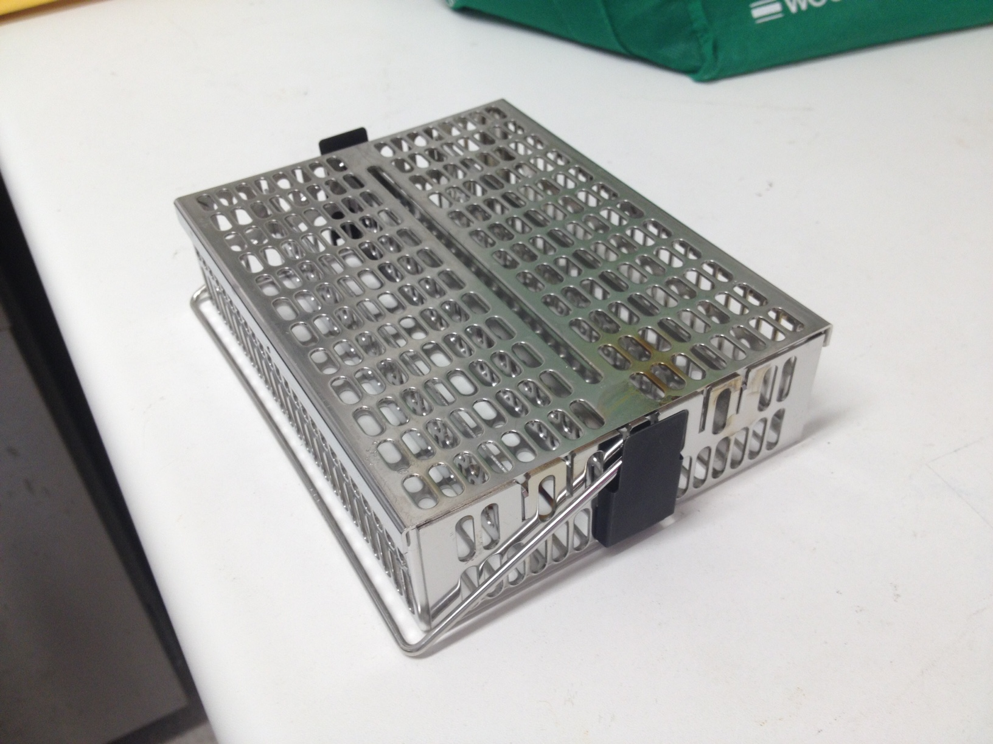  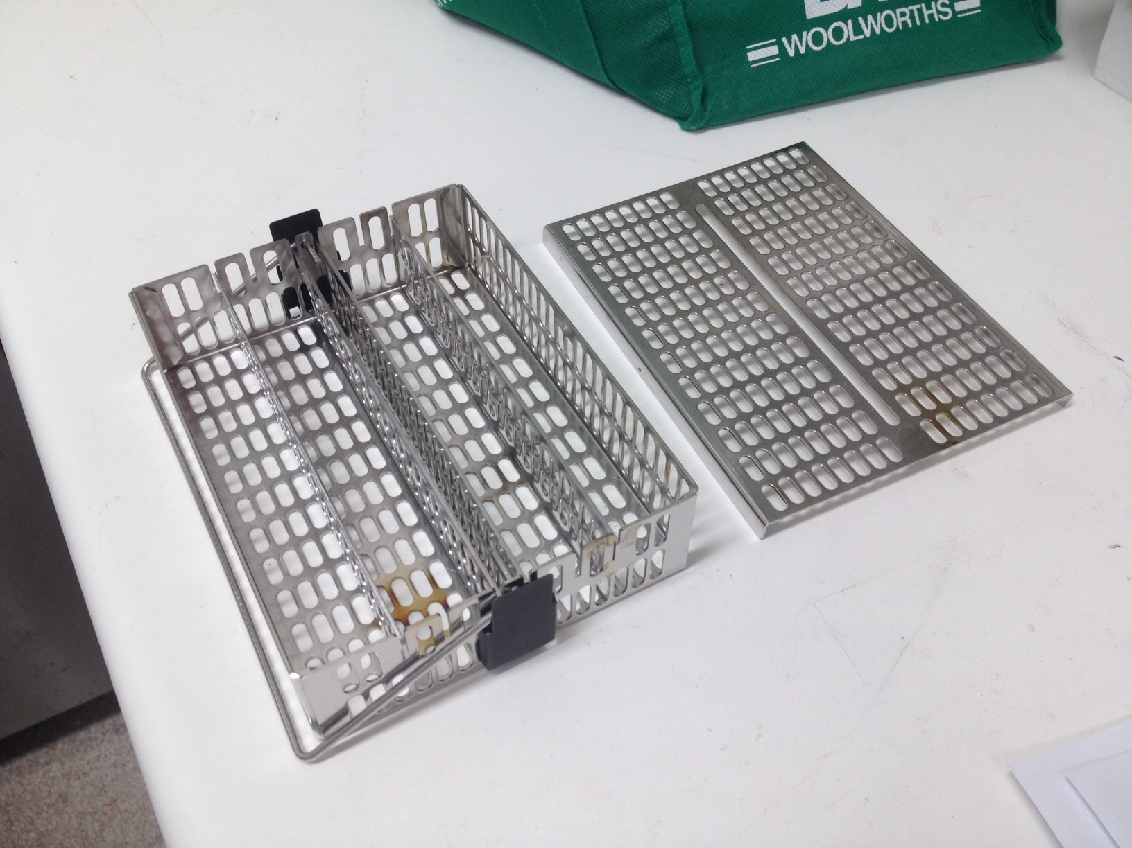  - Open and remove rack lid  - Place histocassettes into racks within the four columns  - Fill racks to almost maximum capacity before adding a second rack  - Replace lid onto rack  - Before bring specimen racks to processor validate the fill levels on all visible chemicals  - Open chamber by rotating the latch clockwise 45 degrees until alarm sounds for 10 secs  - Post alarm continue turning latch clockwise until 90 degrees from origin  - Open the lids and place rack into the processing chamber  - Repeat if second or third rack is required  - Close lid and lock in place by turning latch 90 degrees counter clockwise  - Press routine overnight processing  - Type in total number of specimen cassettes  - Press yes to start  - Close door of fume hood  Removal of cassettes  - Clean bench space for placing cassettes and cover with towel or benchcoat  - Press tray drain button on the tissue processor  - Open the wax tray on the embedding centre  - Obtain a sufficient amount of paper towel  - Open chamber by rotating the latch clockwise 45 degrees until alarm sounds for 10 secs  - Post alarm continue turning latch clockwise until 90 degrees from origin  - Open the lid and Lift the top rack from the processing chamber  - Clean excess wax from outside while rapidly emptying into embedding centre or on bench coat  - Repeat if second or third rack is required  - Clean the embedding chamber with paper towel to remove excess wax  - Specifically clean the fill level sensors with paper towel  - Clean excess wax from processing racks, each piece  - Melt away excess wax with heat gun into metal bucket  - Cleans racks with rapid wipes of paper towels  - Put rack back together as original  - Replace racks into tissue processor  - Press extended clean on the tissue processor  - Close door on fume hood  - Post cleaning press OK to silence machine  - Open chamber by rotating the latch clockwise 45 degrees until alarm sounds for 10 secs  - Post alarm continue turning latch clockwise until 90 degrees from origin  - Remove clean racks from the tissue processor  - Turn off fume cabinet
Legislative requirements | - AS 2243.6 Safety in laboratories, mechanical aspects

Date of Issue: 30 October 2014 Date of next review: October 2019

