School of Biomedical Sciences
Standard Operating Procedures

Title | 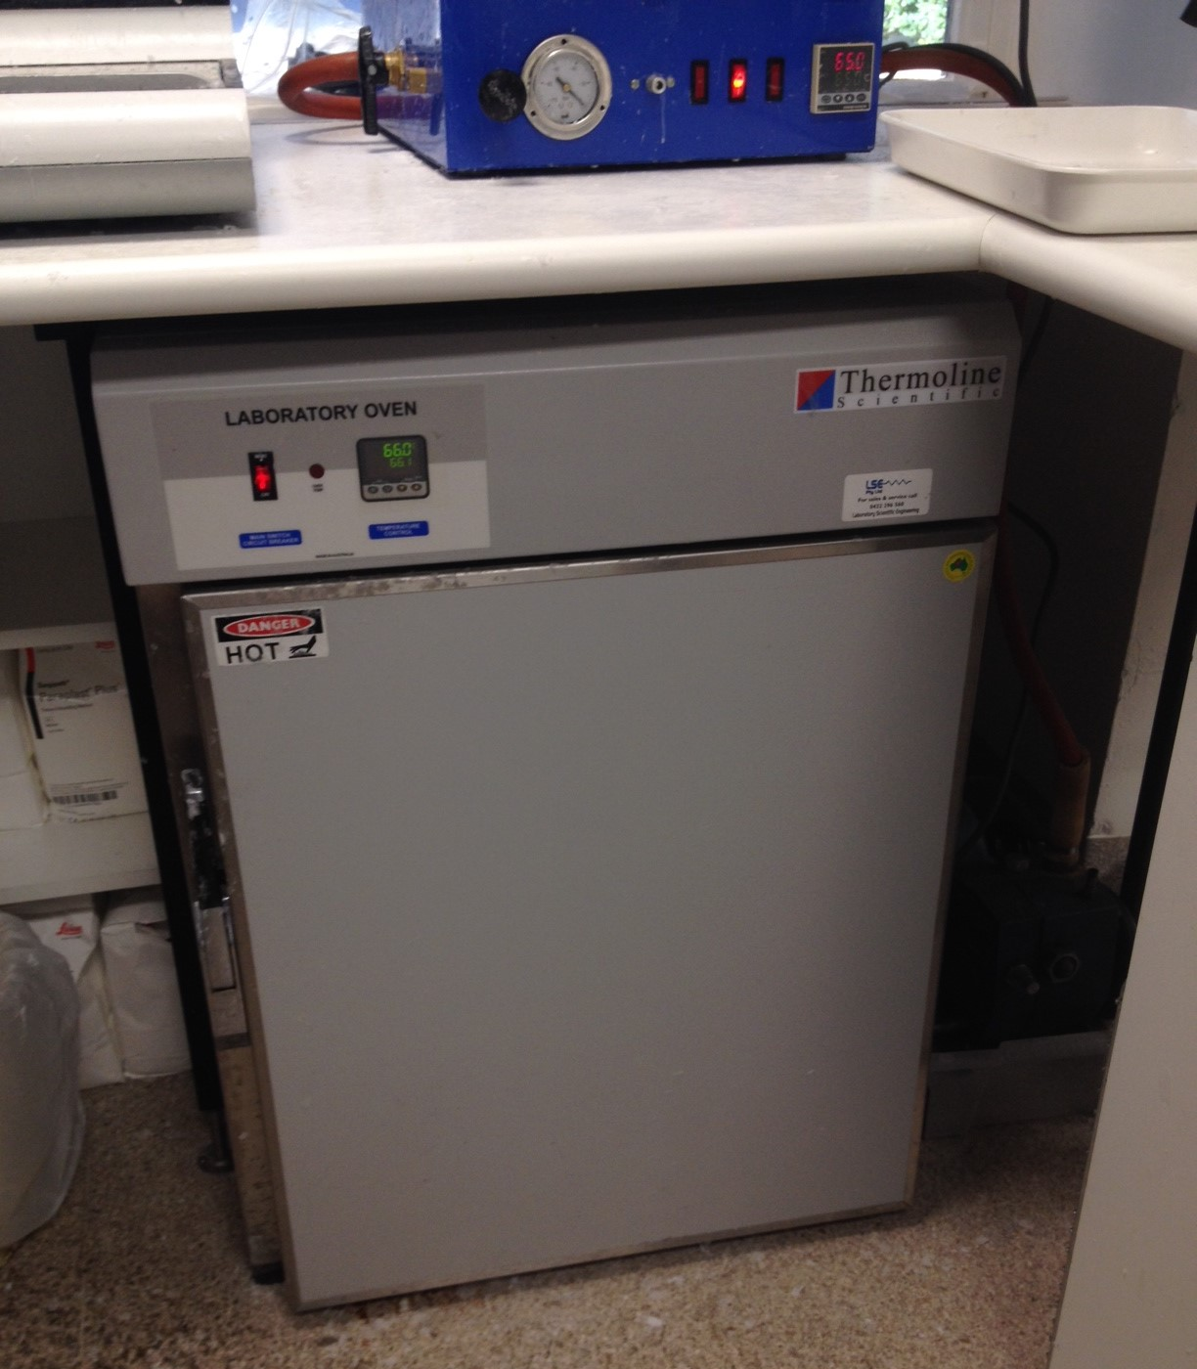  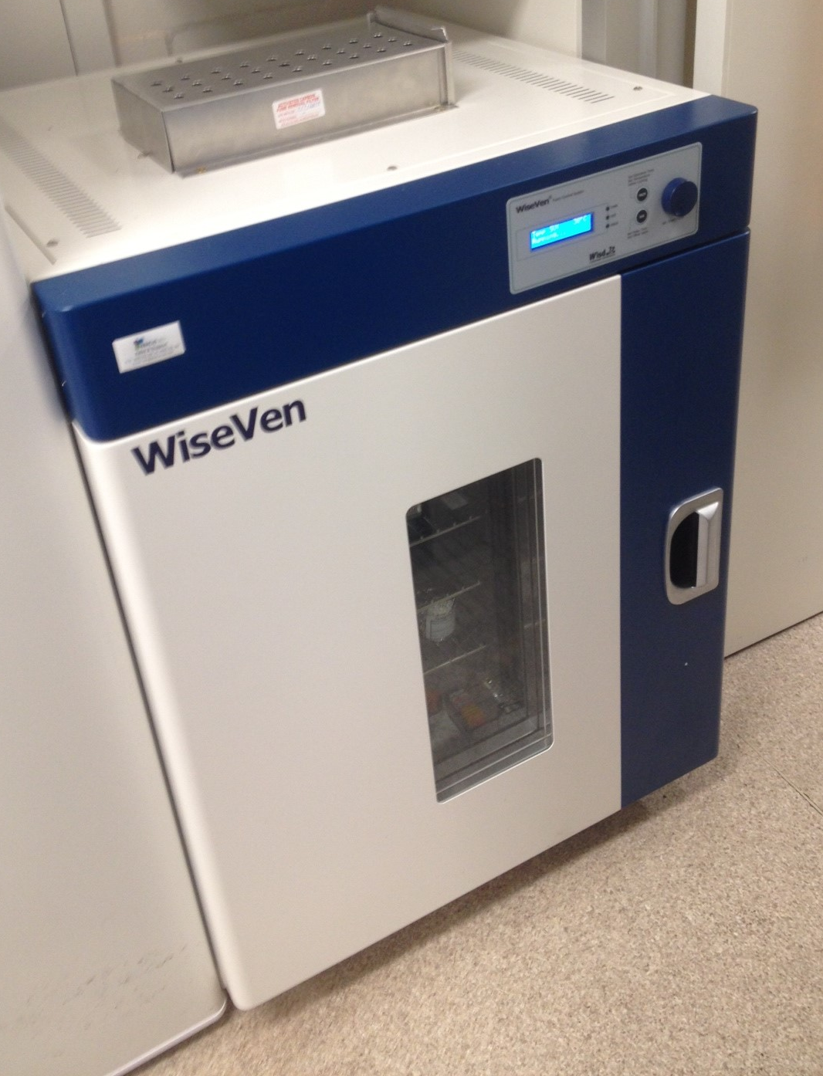  Use of 37ºC / 65ºC incubating ovens  37ºC 65ºC
Date | 30 October 2014
Location | Bld: 64 Room: 126
Equipment  Custodian | Contact: Darryl Whitehead | Expert User:  Darryl Whitehead
Task | Users may choose to use the incubating ovens for various reasons. Usually the 37°C oven is used for drying tissue mounted slides and incubating tissue samples. Usually the 65°C oven is reserved as a hot wax oven and wax tissue processing.
Pre start checks | - Complete SBMS OH&S Induction and local histology induction  - Obtain equipment specific training provided by the Senior histologist  - Read and understand SOP and Risk Assessments  - Notify Histology staff if you will be storing samples or slides in ovens for a lengthy period.  - Check oven temperatures daily to ensure correct temperature.  - Check 65°C oven has sufficient wax for tissue processing.
Safety considerations | Personal Protective Equipment (PPE):  - Lab coat or gown  - Fully closed shoes  - Gloves  - Safety glasses as required  General precautions:  - Be away of slides or samples belonging to other users when using ovens.  - If placing samples into ovens, ensure no spills occur.  - If placing mounted slides into ovens, ensure they have dried sufficiently in the fume hood (at least 90 minutes) before removing them from the fume hood.  - Always ensure door is properly closed after use.  - Emergency Procedures:  In the case of emergency,  All incidents should be reported to the Facility manager, Ext 51929, Safety manager, Ext 53221, and/or Security 53333.  All injuries must be reported to SBMS OHS either to Robyn Oram, Ext 53221, Neville Barry, Ext 53105, Bruno Ray, Ext 52724, or Lawrie Myers, Ext 51269.  All incidents and injuries must be recorded in the UQ Incident and Injury Database.
Procedure | For 37°C oven:  - Check oven temperature is correct. Place a thermometer into the oven if unsure. The oven will beep if the door is left open too long.  - Check slides and samples are dried and have no leaks. Wipe sample containers.  - Place slides or samples on a metal rack, and slide into a rack holder. Some samples may be placed into plastic racks and placed on the benchcoat on the bottom of the oven.  - Close the door of the oven tightly.  For 65°C oven:  - If using hot wax for tissue processing, check there is enough hot wax 1 day prior.  - Check oven temperature is correct. Place a thermometer into the oven if unsure.  - Only place glass or metal materials into this oven.  - If there is a wax spill, empty the catch tray on the bottom and replace it.  - When pouring hot wax into and out of beakers, if hot wax is too high in temperature, where heat protective gloves to avoid burns.  - When processing is complete, close the oven door tightly.
Legislative requirements | - AS 2243.6 Safety in laboratories, mechanical aspects

Date of Issue: 30 October 2014 Date of next review: October 2019

